Lab 1 – Walmart Site Selection

## Background

GIS is used by major corporations around the world to help manage shipping, inventory, sales, marketing, facilities, and expansion. Specifically, with respect to expansion, GIS is used extensively to help determine the most appropriate placement of new store locations.

This exercise will assume that the Walmart Corporation is interested in building a new store in Utah County. To conduct this analysis, you will need to create and acquire many data layers that correspond to different spatial considerations and criteria. Once you have acquired the data needed, you will use spatial analysis to identify the most suitable locations for the new store. You will use multiple geoprocessing tools to conduct this analysis. At the end of the lab, you will generate a map that shows potential locations for new Walmart sites in Utah County and make a recommendation for a specific site.

## Problem Statement

There are over 4,700 Walmart stores in the United States. About 90% of Americans live within 15-miles of a Walmart. Walmart has stated that its goal is to provide inexpensive products to its customers. They provide a large variety of goods, allowing customers to save money without having to price shop (Fishman, 2006). Walmart is likely to continue to expand as population increases and the demand for inexpensive products increases.

Assume that you work for Walmart and have been assigned to select a new location for a store in Utah County. As you might suspect, there are many factors that govern the placement of a new store in a community. Some factors are based on physical requirements, others on political and economic issues. For example, see this article on siting a bicycle and ski equipment sales and rental shop in Wisconsin: <https://community.esri.com/community/education/blog/2012/08/10/siting-a-bicycle-and-ski-equipment-sales-and-rental-shop-in-wisconsin>

Suitable development areas can be determined by creating layers based on limiting criteria and combining those layers to find the places that meet all the criteria. For this lab, you are tasked with identifying the most suitable locations in the county for the placement of the new Walmart store.

## Spatial Considerations

For the purposes of this exercise, the spatial considerations will be limited to the following:

* Proximity to other locations: Find locations at least 2 miles away from any existing Walmart.
* Proximity to major roads: Find locations that are within 2 miles of the I-15 freeway or a highway.
* Population Density: Located in a high-density population area with over 5000 people per square mile (Use 2010 Census data).
* Adequate Space: Walmart stores range from 51,000 ft2 to 224,000 ft2 with an average of 102,000 ft2. Find locations where the average Walmart store size would fit without needing to demolish existing buildings.

## Data

The following datasets will be needed for this project. You can either download the data from the suggested sources or create the data you need to complete this exercise. When you download the data, unzip it, and save it to a file created for this lab.

* Utah Counties Shapefile: <https://gis.utah.gov/data/boundaries/citycountystate/>
* This shape­file represents all the counties in Utah, from which you will select the specific county you need. In the **County Boundaries** section, download the zipped **County Boundaries: Shapefile.**
* UDOT Highways: <https://gis.utah.gov/data/sgid-transportation/roads-system/>
* This shapefile represents all the major roads and highways in Utah. In the **Highway Linear Referencing System Routes** section, download the zipped **UDOT LRS Routes: Shapefile**.
* Census District Shapefile: <https://gis.utah.gov/data/demographic/2010-census-data/>
* This shapefile represents the 2010 Census data for Utah. In the **2010 U.S. Census Bureau Data** section, download the zipped **Shapefile: Census Blocks.**
* Current Walmart locations: You need to create your own point feature class containing all Walmart locations in Utah County.

## Analysis Tools

You will use the following new tools in this exercise:

* Select: Used to find and select features from your data layers based on attributes from the attribute table. You will first use it to select Utah county in the counties shapefile. You will also use it in this laboratory to select population districts (represented with polygons) that have a density greater than 5000 people per square mile.
* Intersect: An overlay operation (Bolstad, pp. 357-358) that cuts an input layer is cut based on the extent of the bounding layer. This operation combines information from both input layers within the area of overlap and results in features that contain parts of each input layer.
* Buffer: A proximity operation which creates an area equal to a distance, specified by the user, from a feature (Bolstad, 343). A buffer operation applied to a point feature layer returns a polygon feature layer with a series of circles of a specified distance around each point. A buffer operation applied to a polyline feature set returns a new polygon feature set with a single polygon surrounding each line segment at a specified distance.
* Erase: An overlay operation where the target features are “cut out” or removed at the locations of the input features.
* Add Field: Adds a blank new field to a table of a feature class, layer, or raster that has already been created and has an attribute table.
* Calculate Field: Calculates the values of a field for all objects within a feature class, layer, or raster.

## Example Model

Your Model Builder model *might* look like the following when it is finished. Note that you are encouraged to make your model “your own” by customizing the layout, the labels on the tools and datasets, etc. Make sure your labels are descriptive so that others can understand what each dataset represents and what each tool is actually doing. Do you see any ways that the following model can be improved? For example, a tool labeled as “Buffer” is much less informative than a tool labeled “Buffer (2 Miles)”. Also, in GIS, there are always many ways to accomplish the same thing. For example, you might buffer your data before selection if you think that would work better (though that’s a bad example, because it is better to select some data first and only buffer the selected data). Regardless, you might find other ways to improve your model over this example in terms of both the organization and tools you use, as well as the presentation, layout, and labeling.

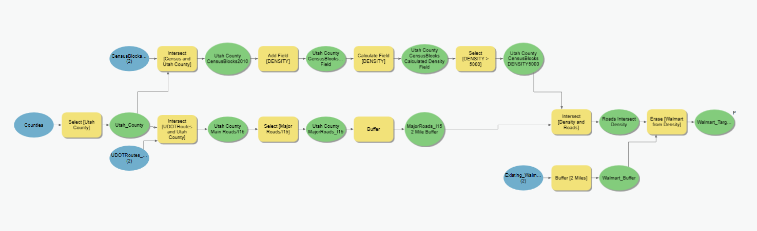

## Complete the Lab

For an advanced GIS student, the information up to this point is all you need to complete the assignment and create an output map from the results. Feel free to try conducting the analysis using only the information provided above. If you complete the lab only using the information provided above (without using the step-by-step instructions below) make sure to indicate this in your lab report to be **considered for extra credit**.

## Step by Step Solution

For all the steps below, give the output layers names that correspond to the layer and geoprocessing tool that you used. This will help you keep your data organized.

### Step 1

Use the **Select** tool to select Utah County from the other counties in the Counties shapefile. Create an SQL expression to select Utah County. This can be done using the expression boxes or by toggling the **Switch to Edit SQL Mode** button and inputting **NAME is Equal to UTAH.** (see Figure 1)

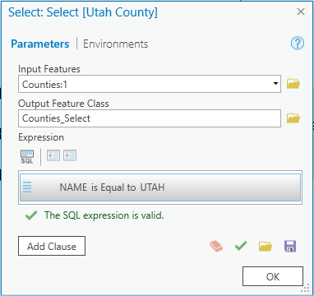

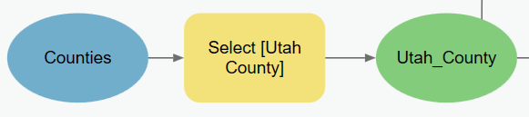

Figure – Select tool window and ModelBuilder Example

### Step 2

Use the **Intersect** tool to clip both the UDOT and CensusBlocks shapefiles to fit Utah County. This reduces the amount of data being processed and allows the analysis to go faster. The tool reads in the first layer as the “cookie dough” and the second layer as the “cookie cutter.” Make sure to select the input features accordingly. (see Figure 2)

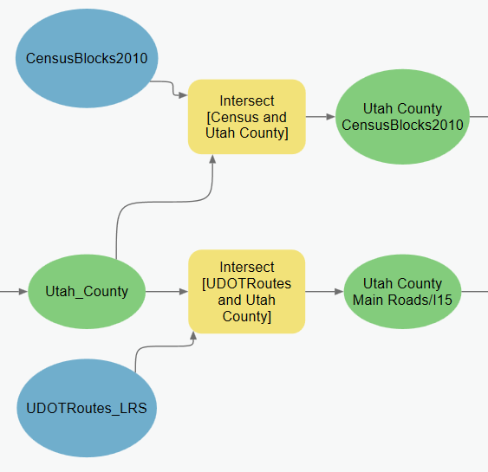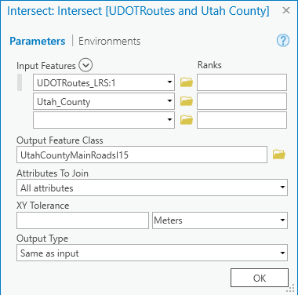

Figure – Intersect tool window

### Step 3

Use the **Add Field** tool to create a new attribute table column called **DENSITY** in the census shapefile. Use the **Calculate Field** tool to calculate the **DENSITY** attribute as the population. To calculate the density, use this statement to compute the number of people per square mile:

**!POP100! / !SqMiles!.** (see Figure 3)

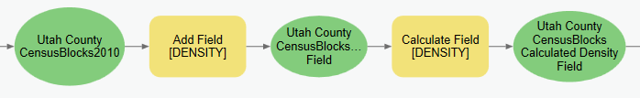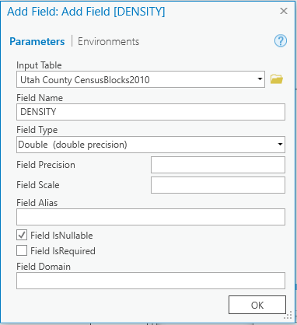 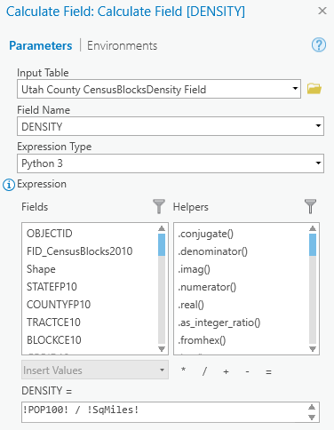

Figure – Top: Model builder example. Bottom: Add Field tool window and Calculate Field tool window.

### Step 4

Use the **Select** tool to select the areas where the population density is greater than 5000. Use the expression **DENSITY > 5000**. Later in the lab you will want to keep the areas inside these polygons. Note that SQL expressions are case sensitive.

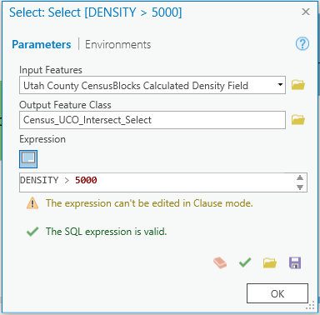

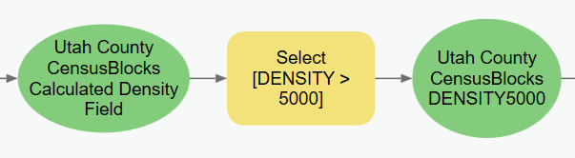

Figure – The Select tool window and ModelBuilder example for DENSITY

### Step 5

Use the **Select** tool to only include the I-15 and highways in Utah County. Create a SQL expression that sets **‘Carto’ to Includes the Value(s) 1, 2, 3, and 6.**

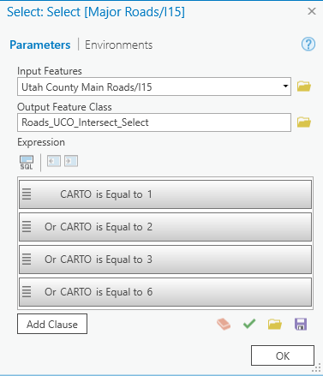

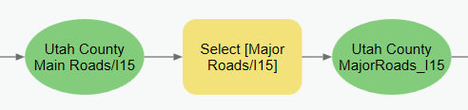

Figure – The Select tool window and ModelBuilder example for major roads.

### Step 6

Use the **Buffer** tool to create a 2-mile buffer around the major roads polyline. Later in the lab you will keep the areas inside this buffer.

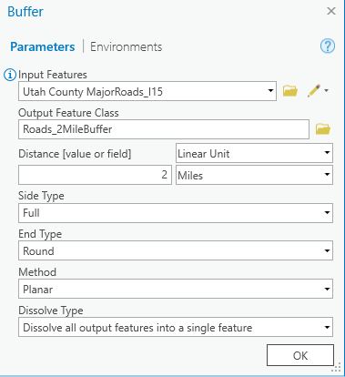

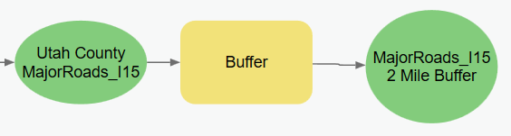

Figure – The Buffer tool window and ModelBuilder example for major roads buffer.

### Step 7

Use the **Intersect** tool to intersect the I-15/major roads buffer layer with the high-density census district layer to find the areas that contain both.

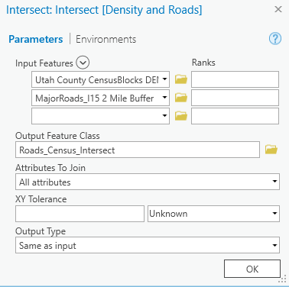 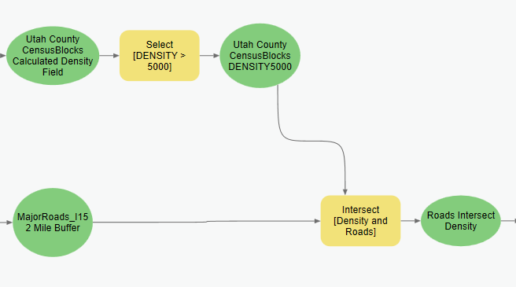

Figure – The intersect tool window and ModelBuilder example of Density and Roads intersect.

### Step 8

Use the **Buffer** tool to create a 2-mile buffer around the existing Walmart’s. Later in this lab you will want to keep the areas outside of this buffer.

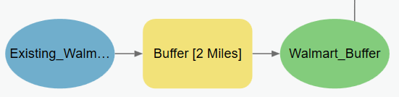

Figure – The Buffer tool around the current Walmart locations.

### Step 9

Use the **Erase** tool to erase the buffered Walmart layer from the intersected population density with major roads buffer layer. This result will give you the target population that is not served by a Walmart. This is shown in Figure 9.

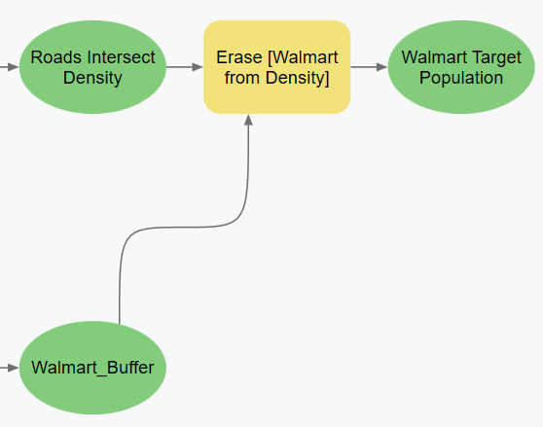

Figure – The Erase tool in ModelBuilder.

### Step 10

Right-click on the last out-put layer you created and check **Parameter** and **Add To Display**. This will make it so that the output will be automatically added to the map.

### 

Figure 10: Parameter and Add To Display options.

### Step 11

Decide where you think the best locations for a new Walmart would be. After running the ModelBuilder, the resulting polygons represent the ideal population that is not served by an existing Walmart. Ideal locations might be an empty field by a polygon. Non-ideal locations would be parks, school playgrounds, and cemeteries. Find and select several locations, show them on your map, and justify in your report why these locations are the best. Create a new point shapefile to mark these points on your final map.

## Deliverables

Make a professional map layout that represents the target zones for building a new Walmart, based on the criteria given. Include **close-up data frames** and an **inset map** of the specific spots you selected for a new Walmart. Write a brief report that describes the project requirements, your approach to solving it, and a **screen capture of the model** you used to solve it. Include your **specific recommendation** on the site for the new Walmart. Also include the **resulting map** and model with a justification for why you chose your specific locations. Make sure to review over the rubric at the end of this chapter for the full requirements of this laboratory exercise.

**Bonus Task**

Repeat the lab exercise with a different store such as Target. Include in your report what data you used, how you acquired it, and what you may have changed to complete the exercise. Include an additional full-page map showing your results.

## References

Bolstad, P. (2008) GIS Fundamentals: A first Text on Geographic Information Systems. 3rd Edition. Esri Publishing.

Fishman, C. (2006) The Walmart Effect: How the World’s Most Powerful Company Really Works – and How It’s Transforming the American Economy. Penguin Books

## Example Map

Note that this map is just an example. Your map will/must look different than this because it will be based on your own analysis, your own unique use of visual graphical cartographic elements and your own layout design choices. Also, your map must include your name.

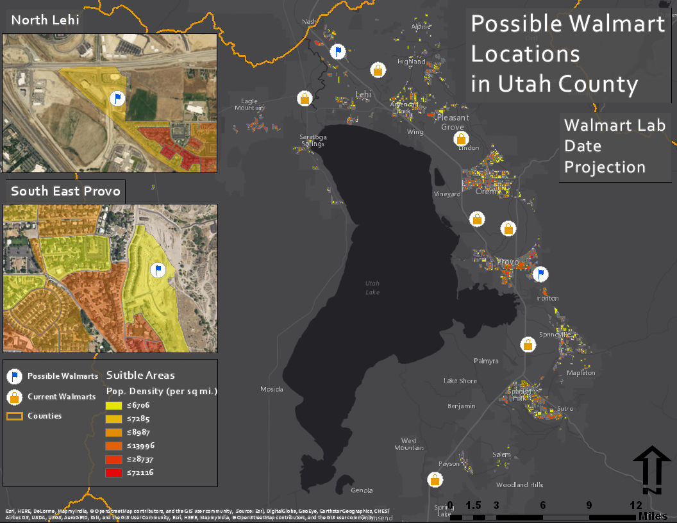

## Rubric for Walmart Site Selection Project Report

|  |  |
| --- | --- |
| Item | Points |
| Assignment Title, Name, Date, Course | /5 |
| Summary of the requirements of the project | /5 |
| Describe your model   * List each of the tools used: (2 pts.) * List tool settings applied for the analysis: (2 pts.) * List all input, intermediate, and output datasets: (2 pts.) * Describe each input dataset including type (point, line, polygon, raster) and the source of the data: (2 pts.) * Describe each output dataset (point, line, polygon, raster): (2 pts.) | /10 |
| * One or more full pages (8.5 x 11) showing your model (5 pts.) * All text is readable (10pt. font minimum) (3 pts.) * All tools and data sets are shown and labels are informative (2 pts.) | /10 |
| * Answer the following questions * Where are the best locations for a new Walmart? (2 pts.) * Which one site do you recommend and why did you select this location? (3 pts.) | /5 |
| Make a full page (8.5 x 11) map showing the identified location(s) for the optimal Walmart site.   * Show current Walmarts and optimal locations for a new one: (5 pts.) * Map Title: (1 pt.), Neat Line: (1 pt.), North Arrow: (1 pt.) * Scale Bar: (1 pt.) * All features (existing & future Walmart locations) are labeled: (1 pt.) * Text box with author name, date, map projection: (1 pt.) * Current Walmart locations marked with an appropriate graphical symbol: (1 pt.) * Base map is visible: (1 pt.) * Zoomed to an appropriate scale for viewing all features: (1 pt.) * All text is legible on printed map: (1 pt.) | /15 |
| **Bonus Task:** Repeat the lab exercise with a different store such as Target. Include in your report what data you used, how you acquired it, and what you may have changed to complete the exercise. Include an additional full-page map showing your results. | Instructor’s  Discretion |